CS 340 Project Two: Grazioso Salvare Dashboard
Student Name: Fisayo G Konigbagbe
Project Overview
This project involves the development of a client-facing web application dashboard for Grazioso Salvare, an organization that trains rescue dogs for specialized missions. The goal of the dashboard is to allow users to interact with animal shelter data stored in a MongoDB database and identify dogs that meet specific rescue criteria.
The application provides an intuitive interface where users can filter data based on rescue type, view results in a dynamic table, and analyze the data using visual charts and a geolocation map. This system improves efficiency in selecting suitable dogs for training by organizing and visualizing large datasets in a user-friendly way.
Required Functionality
The dashboard meets all required functionality as outlined in the project guidelines:
- An interactive data table that displays animal shelter data from MongoDB
- Filtering options that allow users to select:
  - Water Rescue
  - Mountain or Wilderness Rescue
  - Disaster or Individual Tracking
  - Reset (All Animals)
- A dynamic data table that updates based on selected filters
- A pie chart that visualizes preferred dog breeds
- A geolocation map that displays animal locations
- Inclusion of the Grazioso Salvare logo
- A unique identifier (student name) displayed on the dashboard
The dashboard successfully updates all components (table, chart, and map) in response to user input.
Tools and Technologies Used
MongoDB
MongoDB was used as the database system because it is a NoSQL database that stores data in flexible JSON-like documents. This allows for easy integration with Python and efficient handling of large datasets without requiring a rigid schema.
Python
Python was used as the primary programming language to build the application logic and interact with MongoDB using the CRUD module.
CRUD Python Module
A custom CRUD (Create, Read, Update, Delete) module was developed to interface with MongoDB. This module simplifies database operations and allows the dashboard to retrieve and filter data dynamically.
Dash Framework
Dash was used to build the web-based dashboard. It provides both the view and controller components of the application, allowing for interactive UI elements such as tables, filters, and graphs.
Plotly Express
Plotly Express was used to generate the pie chart visualization, providing an easy way to create interactive and visually appealing charts.
dash_leaflet
The dash_leaflet library was used to create the geolocation map, enabling the visualization of animal locations based on latitude and longitude.
JupyterDash
JupyterDash was used to run the dashboard within the Jupyter Notebook environment in Codio.
Steps Taken to Complete the Project
- Imported the Austin Animal Center dataset into MongoDB
- Developed a CRUD Python module to interact with the database
- Connected the dashboard to MongoDB using the CRUD module
- Created an unfiltered data table to display all records
- Implemented interactive filtering options using radio buttons
- Developed MongoDB queries for each rescue type
- Connected filters to the data table using Dash callbacks
- Created a pie chart to visualize dog breed distribution
- Implemented a geolocation map using dash_leaflet
- Added Grazioso Salvare logo and a unique identifier
- Tested all dashboard components to ensure functionality
- Captured screenshots demonstrating all required features
Challenges and Solutions
One challenge encountered was ensuring that the dashboard updated dynamically when filters were applied. This required properly configuring Dash callbacks to connect user input with database queries.
Another issue involved handling MongoDB’s _id field, which caused errors in the data table due to its ObjectId type. This was resolved by removing the _id column before displaying the data.
Additionally, some breed names in the dataset did not exactly match the expected filter values. This required adjusting queries and ensuring proper filtering logic.
These challenges were resolved through debugging, testing, and refining the code until all components worked correctly.
Instructions to Run the Project
To run this project, follow these steps:
- Open Codio and launch the Jupyter Notebook environment
- Ensure MongoDB is running
- Upload the following files:
  - ProjectTwoDashboard.ipynb
  - animal_shelter.py
- Verify that the database contains the Austin Animal Center dataset
- Run all cells in the notebook
- Click the generated link to launch the dashboard
- Use the filter options to interact with the data
Screenshots of Dashboard Functionality
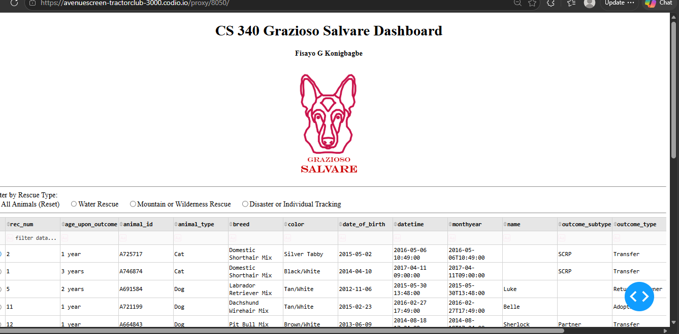
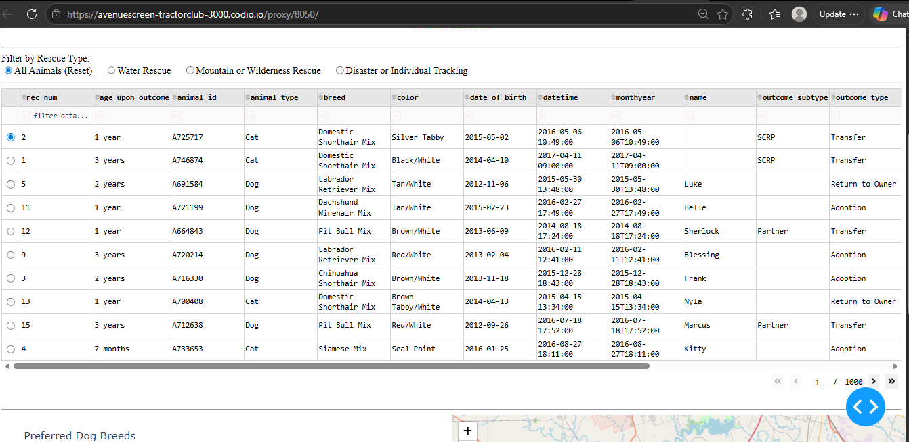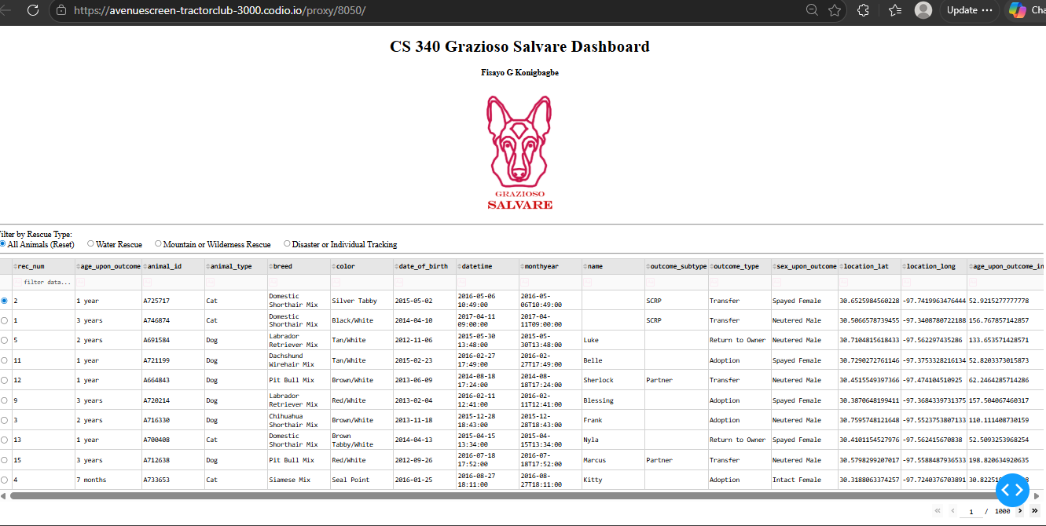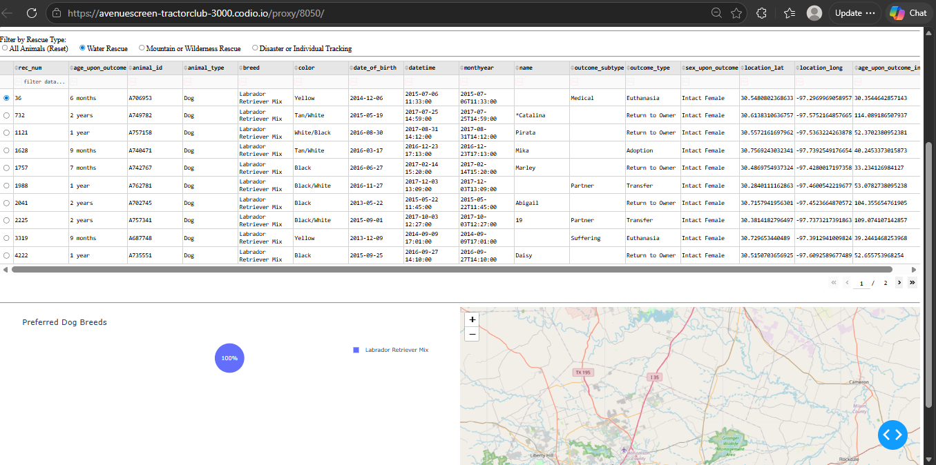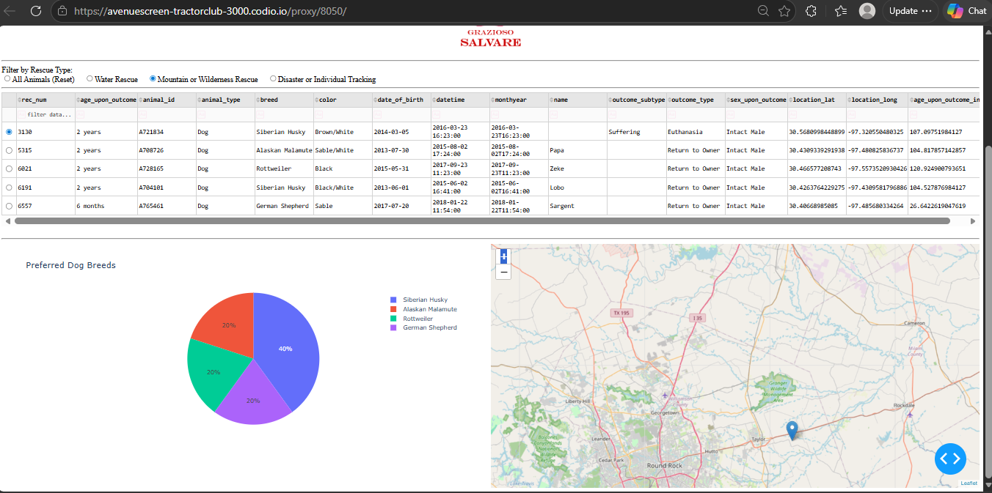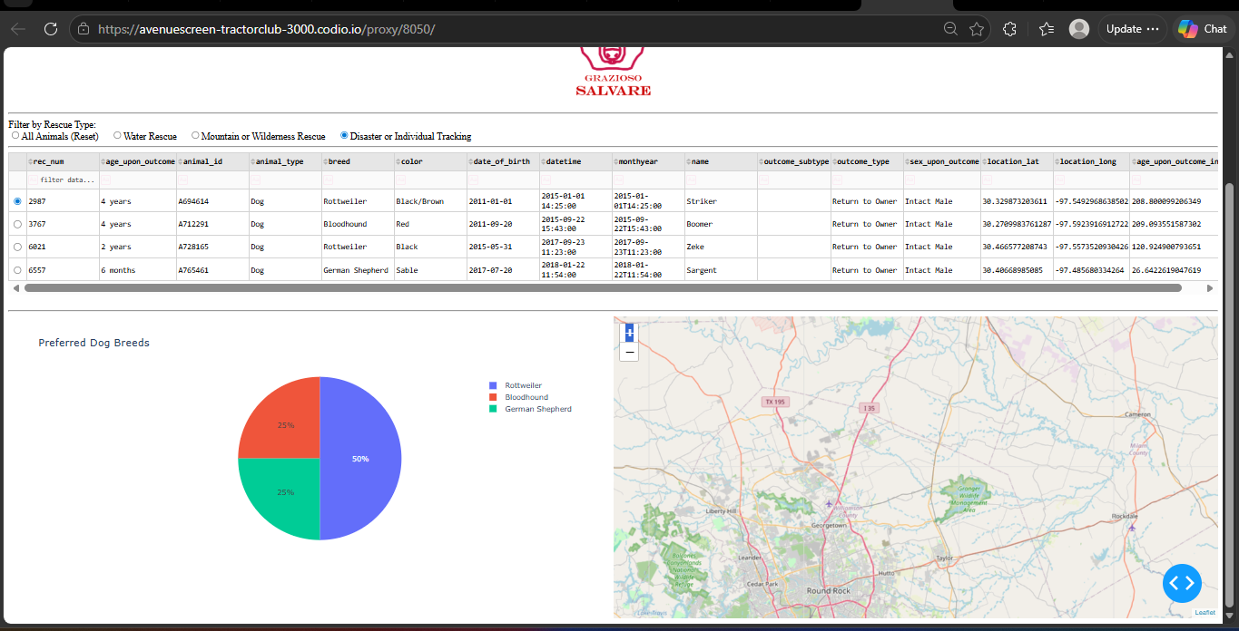
Conclusion
This project demonstrates the successful integration of MongoDB, Python, and Dash to create a functional and interactive client-server application. The dashboard provides an efficient way to filter and visualize animal shelter data, helping Grazioso Salvare identify suitable rescue dogs more effectively.

